**Title**

**“Future Electrical energy issues and next generation Sustainable Energy Management System for IoT devices.”**

Vimal Jaswal1

1 School of Informatics and Engineering, Institute of Technology, Blanchardstown, Dublin, Ireland

[B00122875@student.itb.ie](mailto:B00122875@student.itb.ie)

**Abstract**

An Internet of Things framework can be thought of four different structural components: Smart Devices, Information and Communication technology Gateways, Cloud and Applications. But its proper operation completely depends upon uninterrupted electric energy supply and smooth operations of data centers. This proposal has been made by taking into the consideration of Electrical Energy demand in coming years with increase in connected smart devices, cloud services, wireless technologies and all remote controlled or isolated smart technologies that operate other machines. However, the IoT devices are low powered but the machines these devices actuate will require continuous supply of energy and connection to gateway to work stably. Based on this I have conducted background research and proposing research for software approach for management of IoT enabled devices in future.

**Introduction**

The Internet of things refers to kind of system to associate any device with the Internet-based in specific protocols through information detecting equipment to control information exchange and communications in order to accomplish smart recognition, positioning, tracking, monitoring, and management.

IoT has many applications and in future there would be billions of connected devices in one building. With the increase in usage of these devices the demand of energy by consumers as well as in data centers will increase rapidly. Moreover, these IoT enabled devices will require uninterrupted electric energy supply for smart operation with rare outages. Therefore, an energy management software is required to monitor or control operation of these smart IoT devices to ensure all IoT enabled devices are working correctly and to monitor power consumed by each of IoT enabled devices. The Energy Management Software could be operated as web-based application connected to internet.

**Background**

I conducted the literature review of several articles to find a topic that needs further investigation and might be very useful according to future perspective in growing applications of smart objects and services in Internet of things technologies. From the analysis I observed that sustainable Electric Energy supply is required for all IoT connected devices uninterruptedly for operation. Moreover, an easily manageable software will be required by each building owner to know about the status of their smart objects in building and to observe any failure to the smart device to repair, replace or maintain that easily or provide alternatives with respect to smart services. The main objective is to reduce outages and electricity consumption to minimise energy use and expense and alternatively balancing energy demands in future of smart objects operating everywhere.

The review also mentioned the issues with present Energy challenges. The Industrial internet organisations, software companies, big data centers and Smart grids are using enormous amount of energy and utilises energy management solutions as well and still faces energy challenges outages, system crashes or ambiguous operations.

But as the increasing trend towards a lot of smart devices connected in future will result in increase of role of data centers as well management of energy consumption in every area. Smooth operation of large number of Smart devices will only depend upon well managed electric energy supply everywhere in all buildings, data centers, Internet network providing organisations and energy resources.

**Research Questions:**

What would be effect on Electric Energy demand if Internet of Things and communication technology boom in future?

Would we be able to provide sustainable electric supply for smart devices and services?

The Research work require attention in this area to better understand resilient and continuous operation possibilities of smart objects, Energy conservation techniques and checks and maintenance of smart in future.

**Morley *et al.* (2018)** argued that the electricity consumed by information and [communication technology infrastructures](https://www.sciencedirect.com/topics/engineering/communication-infrastructure) is of  accelerating importance as a share of worldwide electricity use, and as a possible contributor to peak electricity demand at a national scale. They additionally mentioned that this subject has not received a lot of attention among energy analysis literature, nor among discussions of energy policy: on the far side the potency of network devices and knowledge centres. [They](https://www.sciencedirect.com/science/article/pii/S2214629618301051#sec0010) reviewed about the size of Internet-related energy demand, explains why attention to everyday practices, as interconnected with policy and provision, can help to provide insight into these changes and outlines a number of approaches to this, developed a discussion of the patterns of peaks and troughs in [Internet traffic](https://www.sciencedirect.com/topics/engineering/internet-traffic) and to what extent they align with national peaks in electricity demand. They analysed real time internet usage data and traffic reports to investigate and calculate data demand by consumers. Based on data demand, they proximately analysed growth in demand of energy. They concluded that both demand in data centers and energy demand are of utmost importance to maintain balance, stability and providing efficient services to consumers.

**Marinakis & Doukas (2018)** investigated thatEnergy demand is one in all the foremost crucial and varied issues for smart Cities. consequently, the rise in energy demand is turning into associate irreversible because the quality of life is being improved, in addition because the continuous increase of the population. This continuous increase in energy demand including restricted typical energy reserves area unit the most factors tributary to the rise in energy issues, which each smart city can ought to resolve.  
They analysed many accessible tools that support energy end-users in observation, managing and optimising their energy consumption. These tools are principally employed by energy/facility managers, Energy Service Company (ESCOs) and specialists, who create selections supported the knowledge they get. They aforesaid that the accessible solutions focus principally on energy knowledge visualizations and notifications.

They purposed an IoT based framework. The additional worth of the IoT-based System consists in correlating numerous styles of time period knowledge from totally different sources, thence desegregation totally different systems, so as to realize intelligent energy management of buildings, and, probably, districts. Moreover, the degree of generalization of the system makes this advanced tool simply elastic to buildings/cities with totally different options relating to, as an example, styles of buildings, energy infrastructures and energy demand and not simply centred on specific sectors or building targets. It brings along ancient observation systems, low-scale energy management systems and IoT practices, so as to realize sensible energy management.

They conclude that ICT-based solutions that exploit web of Things (IoT) technologies will contribute considerably to energy saving, by motivating and supporting activity amendment of the buildings’ occupants.  IoT-based system facilitates energy end-users to grasp what proportion energy is consumed in total and what's the contribution of the particular end-user and different peers there, in addition as get personalised recommendations of actions for energy conservation and cargo shifting, together with associate estimation of their impact on energy use and user comfort.

**Terroso *et al.* (2019)** investigated that Buildings are known to be the largest end-use energy contributor followed by transport and industry, and therefore they are a clear target for potentially reducing global energy consumptions.

Their present work purposed design frameworks for two different lines of research, the management of energy data and the implementation of IoT platforms. Due to the importance of the building sector in the end-use energy consumption, it becomes a foremost task to achieve meaningful energy savings that will reduce this energy use in reality.

They conclude despite the fact that IoT technologies have been widely used for the realization of the smart building concept, the simple sensorization of buildings is not enough to make a housing stock that consumes fewer energy resources a reality. IoT is also required to properly process, manage and, above all, analyse the energy-related data that would help to develop final energy-aware services targeting the energy efficiency goals.

**Ejaz *et al.* (2017)** investigated that The Internet of Things offers many sophisticated applications such as Smart home, Wearables, Smart City, Smart grids, Industrial internet, connected car, Connected Health, smart retail, Smart supply chain, Smart farming etc. and require sustainable and smart operations. IoT enabled devices should not be overseen as computers that require their Users to arrange and adjust them to specific circumstances. Smart things, which are frequently just occasionally used, need to set up associations immediately, and ready to arrange and design themselves to suit their specific condition.

They provide a unifying framework for energy-efficient optimization and scheduling of IoT-based smart cities for reliable, resilient and efficient operations. They suggested predictive models for energy consumption, use of lightweight protocols, cloud-based approach, low power design and cognitive management framework.

They conclude that the framework may help in energy efficient operation and reduced costs and in future Fog or edge computing can lead to energy saving for most of the IoT applications; therefore, it is important to study energy consumption of fog devices for IoT applications and require extended work on security.

**Pan *et al.* (2015)** investigated the effect of IoT experimental testbed on Energy efficiency and building intelligence research. Their objective was to build an IoT system in homes or workplaces to empower multi-scale Energy proportionality in addition make an intelligent home space.

They proposed three experimental methods in their research. They assembled a one of a kind IoT trial testbed for energy efficiency and building intelligence research. They monitored and gathered one-year-long building Energy utilization information and afterward deliberately assess and break down them. They propose an IoT system with area based computerized and organized Energy control, which utilizes cell phone location and distributed computing advancements to empower multi-scale energy proportionality including building, client and authoritative level energy proportionality. They additionally manufacture a proof-of-idea IoT system and control framework model and did true tests which shows the effectiveness of the proposed arrangement. They observed in experiments that The heating and cooling frameworks don't effectively accept the outside climate condition as factors to automatically adjust the running schedule to save energy, In summer months the energy usage for cooling is essentially higher as compared to other months, A lot of electrical energy is wasted particularly during afterhours and The actual inhabitancy rate has very low impact to the energy consumption.

They concluded from the results that the actual running process of green buildings may not be energy efficient even if they were ‘green’ by design. The proposed solution by them provided economic benefits in term of energy saving, improving home/office network intelligence, but also put social impact in terms of global sustainability.

**Shrouf & Miragliotta (2015)** Investigated the benefits of adopting Internet of things methodology on Production management or manufacturing. They presented a framework to support the integration of gathered energy data into a company's information technology tools and platforms. Their objective was to highlight how operational and tactical decision-making processes could base on such data in order to improve energy efficiency and therefore competitiveness, of manufacturing companies. They conducted literature review of concepts and theoretical frameworks on energy management practices and the IoT paradigm. They interviewed Production company’s account managers and product managers from the information they collected from their literature review. They gathered data of ten manufacturing companies that have already adopted IoT technology for energy efficiency. They conducted survey to get more information about integration of IoT awareness.

They observed that not all manufacturing companies are aware about role of Internet of Things technology for use of energy efficient manufacturing and its importance in benefiting the company and improving manufacturing productivity with energy efficient techniques integrated with IOT. They concludedthat Energy administrators can approach the Internet of Things reception in an advantage driven way, tending to those Energy management practices that are more lined up with organization development, measurable information and accessible data frameworks and tools.

**Botta *et al.*** **(2016)** Investigated the integration of Cloud and Internet of things on Future Internet trend and applications in Business and Research. Firstly, they conducted background research and survey on basic concepts of Cloud computing and internet of things. Secondly, they observed devices IOT such as sensors, actuators, RFID etc. and its various applications and how these can be connected or integrated with cloud system. Thirdly they conduct research for the various applications of integrating these two different frameworks such as smart healthcare, homes, cities etc. Further, they elaborate various challenges, scope issues that comes into play while bridging gaps of cloud and internet of things and how this paradigm can benefit the society in future. The conclusion they made from this research is that this integration of Cloud Computing and Internet of Things can be referred to as Cloud-IoT and open doors to various business and research practices in future and its various applications would set a benchmark and will have a great improvement in future if Internet.

**Mohanty *et al.* (2016)** investigated concept of Big data and Internet of things technologies and applications on design framework of smart cities. They Gathered information on requirement and implementation benefits of smart cities illustrating various components and sub components related to infrastructure and smart city design and elaborating concept of big data and its importance, requirement, complexity and management in case of smart city. The conclusion they made is that the concept smart city is very wide, and its maintainability totally depend upon the maintenance and handling challenges and issues of big data**.**

**Wei & Li (2011)** investigated on building energy-saving demand and intelligent building energy monitoring. They proposed a system framework of Building Energy Monitoring and Analysis System based on the Internet of things, which has some enlightening in Building energy consumption further to accomplish live monitoring and control and improve the energy-saving of intelligent building. They discussed the comprehensive analysis of energy consumption monitoring and management system from the Internet of Things technology combined with intelligent building applications. In their paper, based on wireless sensor networks and using Internet of Things technology they conduct a comprehensive analysis of building energy consumption on intelligent building automation systems and equipment. The tried to make full use of the inherent advantages of sensor networks collecting environmental information on energy consumption and proposed a design framework based on integrated management of building energy consumption monitoring and analysis system through Internet of Things, to make the role of better ideas for the level of building energy-saving technologies.

**Ferreira *et al.* (2018)** describes the development and implementation of an electronic platform for energy management in public buildings. They aimed a sustainability program with goals for Electricity consumption reduction oriented for two main problems; Heating/cooling systems and lighting control with human presence. Secondly, Online information about the electricity consumption, where the collected data from smart meters contributes to future decisions and provides online data about consumption. Thirdly, Changing the users’ behaviour through enhancing their perception of unnecessary consumption allowing them to contribute to collective savings in public buildings or shared spaces.

The developed prototype was on basis of the installation of a network of wireless sensors using the emerging Long Range (LoRa) low power long-range wireless network technology. This network collects sensor data, which is online stored and manipulated to extract knowledge and generate actions toward energy saving solutions. In this process, gamification approaches were used to motivate changes in the user’s behaviour towards more sustainable actions in public buildings.

They Observed that These actions and the associated processes can be implemented as public services, and they can be replicated to different public buildings, contributing to a more energy-sustainable world. The developed paradigm enables to managing and monitoring of the cooling or heating, electric power consumption, and lighting levels. For verification of the proposed electronic platform, sensor information was collected in the context of a university campus, which was used as an application scenario in public buildings. They concluded from their testing model and data analysis that the energy consumption reduces, and the work can be extended in future for management of Energy Wastage.

**Aims and objectives**

The goal of this research will be to design and develop a software based approach to visualize, monitor or control the Energy consumption online on application by employing smart plugs, sensors, IoT devices and gateway which enables the communication between the various smart plugs and the web server hosting the monitoring system application, thereby facilitating the user to behave accordingly to decrease usage of power or to provide the reliable power supply.

**Methodology**

New information and communication technology (ICT) consist of these three pillars Internet of things, big data and cloud computing.

Computing practices has Improved and completely changes and rapidly shifting away from hardware-specific computing towards the network service as a software--the network is now having all devices. A simple example is remote control access of your windows Operating system or any type od virtual system that can be accessed via internet communication and cloud services technology.

This is the reason I selected software methodology for my research work. I will try to get deep understanding and knowledge of network operated software techniques, virtual device operations and communication and machine to machine communication technology to head start with my project. However, there are some limitations in numerous software techniques used for IoT enabled devices or Smart Devices. I will have to figure out the methods I will use while conducting my research by Software approach.

IoT enabled devices have one issue challenge that is self-organising or resilience ability. IoT enabled devices should not be overseen as computers that require their Users to arrange and adjust them to specific circumstances. Smart things, which are frequently just occasionally used, require to set up associations suddenly, and ready to arrange and design themselves to suit their specific condition. But no device is self-organising in nature to the full extent. Smart IoT enables or actuated Devices will always require observation or management and with the rapid growth in ICT technology EMS system for Smart Devices could be the future demand at domestic to all organisational levels.

The Following figures Provides an idea of a Electrical Energy Management Software for IOT enabled, Sensor controlling devices and automation control objects observation, control and maintenance in real time for avoiding outages in Smart IoT devices.

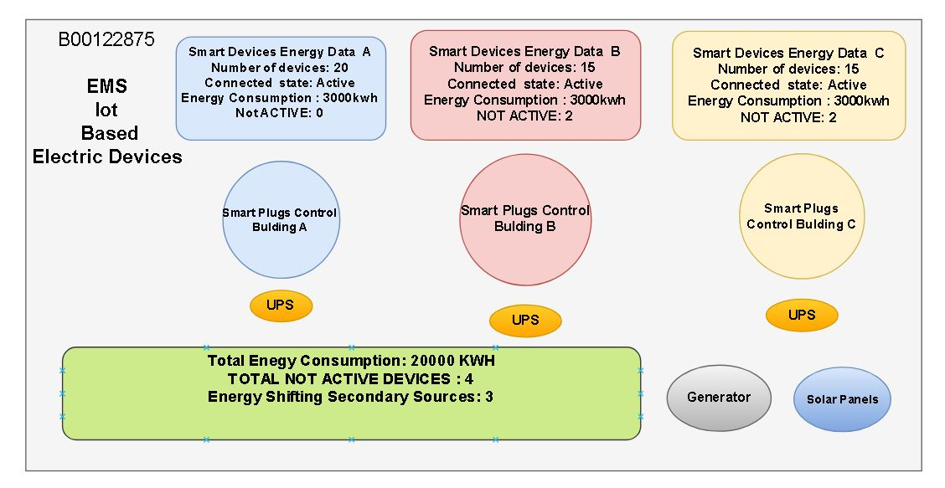

**Research for Software Planning**: This phase will consist of finding all the best possible ways to gather information in detail about various resources and technologies that can be used for design planning of software. Further research on virtual machines, technologies, simulation methods to build an application that can represent the information of different blocks of buildings on one screen.

**Software Design and Simulation Models:** This phase will be development of software design models or simulation methods for representing real world smart devices energy data from different locations onto one main screen. The Design models would be designed to extend any time whenever required. The data models will be modified and refined till a desired level of model is achieved.

**Software Testing and Documentation:** The software and simulation model will be tested and will be further improved through various regression and software testing methods. If all units of software worked well the collaborated software will be tested for integration and then finally would be tested for use with compatible hardware system.

**Realisation of Software or Simulation Model:** This phase would be to gather all hardware components necessary to find practical possible ways to build a hardware model for software system for realisation of Smart Devices energy data on the software application program. Observing and Resolving Software and Hardware related issued to get the system up and running.

**Data analysis and operation testing:** Once the Hardware and software models are ready, it will be tested for observation, data analysis and operational functionality and stability. Any Problems found during this procedure would be checked for resolution.

**Research methods**

1. **Survey:** Prediction of usage demand and growth of Smart IOT application services and estimation of electric energy demand in future.

**Sampling target Population size:** Deciding target audience or population category for statistical research analysis and inferences.

**Time constrained:** Managing and designing survey questions within appropriate conditions of research time.

**Anonymity:** Deciding the appropriate size of population to gather enough statistical data for estimation of services in future.

**Unbiased**: Choosing sufficiently diverse population to ensure that population groupings are not subject to adverse stereotyping.

**Voluntary**: Participation with no mandatory requirement for completion of all questions/sections.

1. **Design of Experiment:** Designing software models for Electric Energy Management utilising current internet of things resources.
2. **Testing and Refining design models**: Conducting design test on software models, development, troubleshooting and fulfilling conditions of desirable design and their testing for execution.
3. **Data Analysis/Regression Analysis:** Calculation of Significance of experimental observations obtained by conducting Research survey, experimental methods and software testing outcomes and documentation of that for upkeeping research records.
4. **Analysing Impact:** Forecastingissues and future research impacts in this context and improvents that can be done based on analysis of data.

**Timetable:**

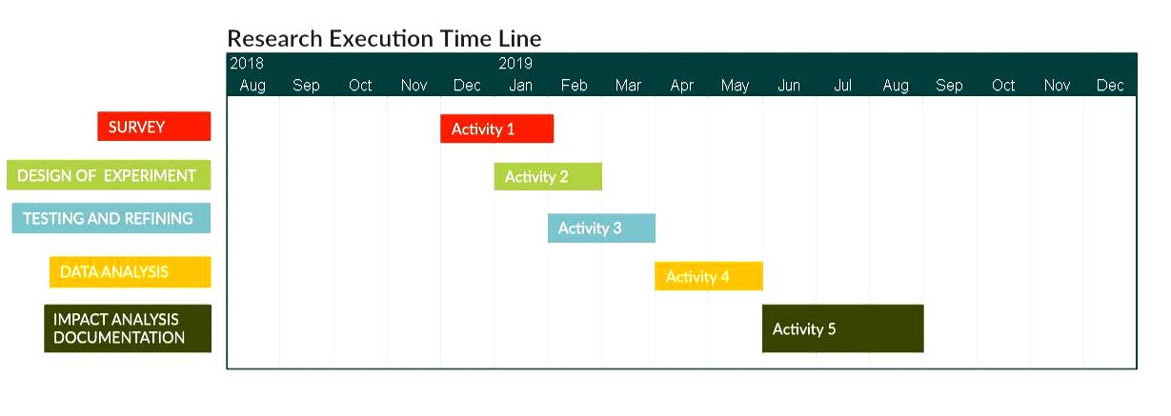

**Budget and Resources**

|  |  |  |
| --- | --- | --- |
| Serial No. | Resources | Estimated Budget (€) |
| 1 | Personnel Equipment | 100 |
| 2 | Software Subscriptions | 100 |
| 3 | Questionnaire Survey forms | 50 |
| 4 | IoT Components apparatus | 200 |
| 5 | Report materials and supplies | 50 |
| 6 | Computer use/data storage | 50 |
| 7 | Purchase of data, periodicals, books, Travel | 100 |
| 8 | Miscellaneous | 150 |
| Total | | 800€ |

**Research impact**

The research area has a lot of opportunities in future as the cloud and IoT based services is rapidly taking cover of traditional way of using devices. Today many of applications of IoT devices are being preferred by people. Remote control and home automation are taking attraction of all people. Therefore, the connected services and machine to machine communication is surely going to take a leap in near future and Sustainable Energy Management of these smart services might become demand of coming generation.

**Dissemination:**

I would distribute my work and documentation in form of thesis and will be providing a copy for the university library, via blog and open repositories.

**References and bibliography**:

[1] Morley, J., Widdicks, K. & Hazas, M. (2018) Digitalisation, Energy and Data Demand: The Impact of Internet Traffic on overall and Peak Electricity Consumption. *Energy Research & Social Science.*38 pp. 128-137.

[2] Marinakis, V. & Doukas, H. (2018) An Advanced IoT-Based System for Intelligent Energy Management in Buildings. *Sensors.*18 (2), pp. 610.

[3] Terroso-Saenz, F., González-Vidal, A., Ramallo-González, A.P. & Skarmeta, A.F. (2019) An Open IoT Platform for the Management and Analysis of Energy Data. *Future Generation Computer Systems.*92 pp. 1066-1079.

[4] Ejaz, W., Naeem, M., Shahid, A., Anpalagan, A. & Jo, M. (2017) Efficient Energy Management for the Internet of Things in Smart Cities. *IEEE Communications Magazine.*55 (1), pp. 84-91.

[5] Pan, J., Jain, R., Paul, S., Vu, T., Saifullah, A. & Sha, M. (2015) An Internet of Things Framework for Smart Energy in Buildings: Designs, Prototype, and Experiments. *IEEE Internet of Things Journal.*2 (6), pp. 527-537.

[6] Shrouf, F. & Miragliotta, G. (2015) Energy Management Based on Internet of Things: Practices and Framework for Adoption in Production Management. *Journal of Cleaner Production.*100 pp. 235-246.

[7] Botta, A., de Donato, W., Persico, V. & Pescapé, A. (2016) Integration of Cloud Computing and Internet of Things: A Survey. *Future Generation Computer Systems.*56 pp. 684-700.

[8] Mohanty, S.P., Choppali, U. & Kougianos, E. (2016) Everything You Wanted to Know about Smart Cities: The Internet of Things is the Backbone. *IEEE Consumer Electronics Magazine.*5 (3), pp. 60-70.

[9] Wei, C. & Li, Y. (2011) Design of Energy Consumption Monitoring and Energy-Saving Management System of Intelligent Building Based on the Internet of Things. *Electronics, Communications and Control (ICECC), 2011 International Conference On.*: IEEE, pp. 3650.

[10] Ferreira, J., Afonso, J., Monteiro, V. & Afonso, J. (2018) An Energy Management Platform for Public Buildings. *Electronics.*7 (11), pp. 294.